*Number and Operations in Base Ten – Adding Within the Thousands (3NBT.2)*

GRADE

3rd

Action Based Learning/MATH

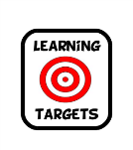

I will use *Math & Movement* Skip Counting Mats and kinesthetic learning to add within the 1,000’s, using place value to compose tens, hundreds, and thousands.

[](https://www.google.com/imgres?imgurl&imgrefurl=http://www.communityschoolnaples.org/page.cfm?p%3D1072&h=0&w=0&sz=1&tbnid=zs_ylVQYEnR7NM&tbnh=190&tbnw=265&zoom=1&docid=fFDgtVSo9oQ_yM&ei=KpZ_Uo_ABKL-4APB7oGYCQ&ved=0CAEQsCU)

MATERIALS

* *Math & Movement* Place Value Hop P1 mat
* *Math & Movement* number cards
* Stackable ones, tens, hundreds and thousands blocks
* *Math & Movement* Adding with the Thousands activity sheet
* Pencils
* Smart Board lessons



* Preparation: write 46 + 51 on the board and have the two numbers displayed on the *Math & Movement* Place Value Hop P1 mat
* “How many ones are in 46?” (answer: 6, place 6 ones blocks under the six)
* “How many tens are in 46?” (answer: 4, place 4 tens blocks under the four)
* “How many ones are in 51?” (answer: 1, place 1 ones block under the one)
* “How many tens are in 51?” (answer: 5, place 5 tens blocks under the four)
* When adding two numbers together you always add the ones place value first.
* Have a student go to the ones blocks and count the number of blocks. There are now 7 ones blocks. Place the 7 number card in the ones column and the 7 ones blocks under the 7 number card.
* Have a student go to the tens blocks and count the number of blocks. There are now 7 ones blocks. Place the 7 number card in the ones column and the 7 ones blocks under the 7 number card.
* Select a student to jump on the mat to read the answer to 46 + 51 = 97, jumping on the 9 saying “nine” then jumping on the T saying “t” (As in 9t or ninety) and then jumping on the 7 and saying “seven” and then say “Ninety-seven.”
* Preparation: write 38 + 27 on the board and have a student build the numbers on the *Math & Movement* Place Value Hop P1 mat with number cards and ones and tens blocks.
* When adding two numbers together you always add the ones place value first.
* Have a student go to the ones blocks and count the number of blocks. There are 15 ones blocks.
* “Now we have the number the number 15. Can we put the number 15 in the ones column for your answer?
* We can’t because the number 15 has tens and ones.
* “How many tens are there in the number 15?” (Place ten of the ones block together to form a ten.)
* “You now have an extra ten. Let’s put it in the tens column with the 3 and 2 from the 32 and 27.
* “How many ones do we have left?” (5 ones)
* Have a student place the 5 number card and five ones blocks in the ones column on the Place Value Hop Mat.
* “Let’s add the tens.” (6 tens…place the 6 number card and 6 tens blocks in the tens column.
* Select a student to jump on the mat to read the answer to 38 + 27 = 65.
* Repeat these steps with 56 + 39 and 17 + 46.
* Once students understand carrying to the tens place; have them solve 263 + 182 and then 771 + 355.
* Once students understand carrying to the hundreds place; have them solve 1,236 + 3,45 and then 3,637 + 1,284.

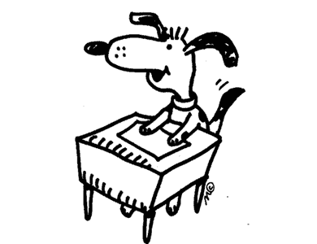

STUDENT WORK TIME

* Have students complete the *Math & Movement* Adding with the Thousands activity sheet
* You will have 8 minutes to do this.